Amateur Chamber Music Society

<http://www.acms-australia.org/concerts/>

— PROGRAM —

COMPOSER *Name of Piece For Example Trio No 6 in A major Op 30 No 1*

(1) Movement name (2) For example Adagio  
(3) Movement name

instrument Player Name instrument Player Name  
cello for example Player Name

duration, for example 17’

COMPOSER *For Example Quartet in D minor Op 3  
First Movement*

(1) Movement name

instrument Player Name instrument Player Name  
instrument Player Name instrument Player Name

13’

COMPOSER *For Example Piano Quintet in  
A major D 667 "The Trout”*

(1) Movement name (2) Movement name (3) Movement name  
(4) Movement name (5) Movement name

violin Firstname1 Surname1 viola Firstname2 Surname2  
cello Firstname3 Surname3  
double bass Firstname4 Surname4  
piano Firstname5 Surname5

35’

— refreshments —

- Notes -

COMPOSER (18xx–19yy) *Name of Piece For Example Sonata No6 in A major Op 30 No 1*

Qwerpo qerpoiu qqeropiu Qwerpo qerpoiu qqeropiu This sonata for piano and violin is rarely heard in concert performances these days. Considered by its Qwerpo qerpoiu qqeropiu.

For example dedicated to Tsar Alexander I of Russia, it features sudden dynamic contrasts for which Beethoven became so well-known, but the overall character is one of elegance, gentleness, tenderness, and poise.

For example piano opens the first movement with a rhythmic motif that seems to be a truncated version of the opening of the earlier “Spring” Sonata No5. The motif also occurs repeatedly as the development section transitions back to the recapitulation. The same occurs again in a much more dramatic form as the opening of Beethoven’s companion Sonata No7 (Op30 No2).

For example Beethoven was a master of variation. The violin opens the second movement, Adagio, with a simple theme which is repeated twice more, separated by increasingly complex variations of the second subject. The movement has moments of tenderness as well as operatic lyricism and passion which is never overdone.

(Much of the above adapted from <http://www.gotomidori.com/english/musicnote-200302/musicnote46.html>.)

COMPOSER (dates) *Quartet in D minor Op 3 (date of composition)*

For example musical talent of Vienna-born Alexander Zemlinsky became evident at an early age and already aged 13 he was enrolled in the Conservatory of the Society of the Friends of Music. He was greatly influenced by Brahms, who at the time was serving as President of the Society.

For example. When he showed his Trio in D minor for Clarinet, Cello and Piano to Brahms, Brahms was mightily impressed and immediately recommended that his own publisher Simrock print the work.

For example. The music of Alexander Zemlinsky has come to the attention of an increasingly wide public over the past quarter-century. Some of his songs have been recorded with those of the better-known Gustav Mahler.

The *Quartet Op 3* shows the influence of Brahms in its formal structure, but the musical language is closer to Wagner. The first movement played tonight is in the full late Romantic style, while still observing the traditional sonata movement form. It takes up almost half of the performance time of the complete work. The trio ranks among his most performed works.

(Adapted eg from http://www.editionsilvertrust.com/zemlinsky-trio-op3.htm. and <http://www.naxos.com/catalogue/item.asp?item_code=8.570540>)

COMPOSER (1797-1828) *Piano Quintet in A major D667 "The Trout”*

For example: Schubert was 22 when he and a group of friends met to play Hummel’s quintet for piano, violin, viola, cello and double bass, a most unusual combination. They wanted something else for the same group, so Schubert wrote this Piano Quintet nicknamed “The Trout” because the fourth movement is a set of variations on his song of the same name. The rising sextuplet figure from the song's accompaniment is used as a unifying motif throughout the quintet, and related figures appear in four out of the five movements – all but the Scherzo. As in the song, the figure is usually introduced by the piano.

(Adapted from various hits on the internet.)

PayPal



BSB 032101

A/C 139251

concert organiser Firstname Surname

light refreshments (wine, juice and savouries)  
$15 admission ($10 concession/seniors)

To get information on future concerts, go to the website  
[www.acms-australia.org](http://www.acms-australia.org/)  
All chamber music players are welcome to join the  
Amateur Chamber Music Society. Visit our website for more information.



**CHAMBER MUSIC CONCERT**

3 pm Sunday dd mmmm 2yyy

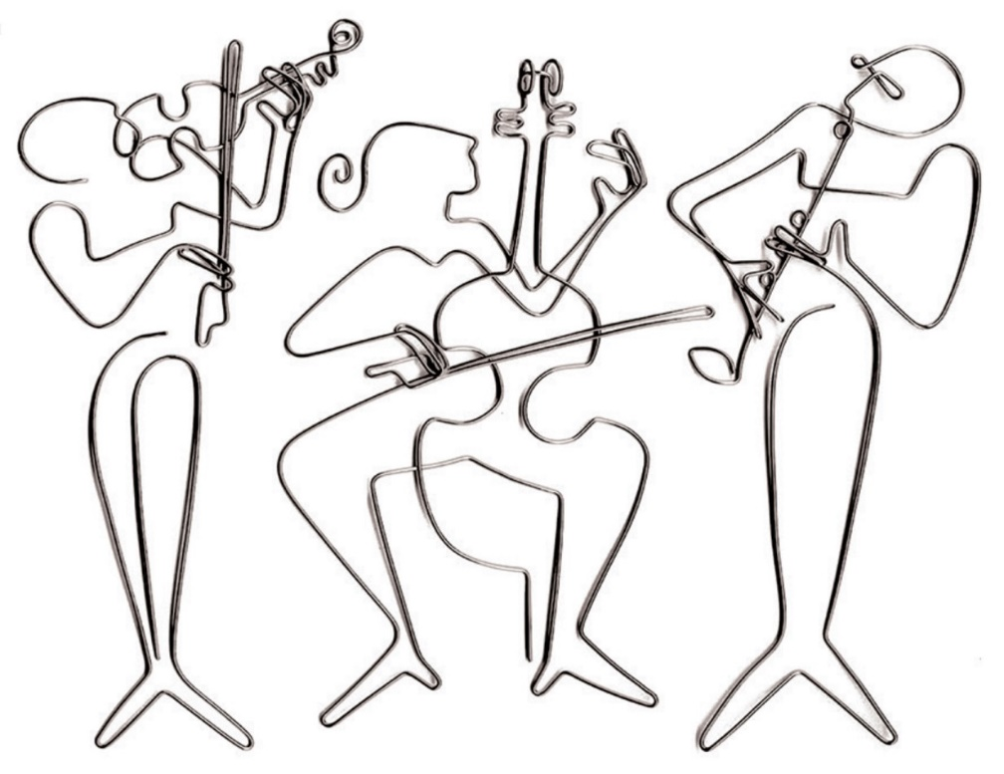

Steve Lohman  
[lineartgallery.com](http://lineartgallery.com)

The Kirribilli Neighbourhood Centre

16-18 Fitzroy St Kirribilli

[www.thekirribillicentre.org](http://www.thekirribillicentre.org)