— program —
GRIEG Sonata No 3 in C minor Op 45
(1) Allegro molto ed appassionato
(2) Allegretto espressivo alla Romanza (3) Allegro animato
violin George Carrard piano Christine Edwards
25’
Three Pieces for Cello and Piano
BRUCH Kol Nidrei Op 47
SAINT-SAËNS Allegro appassionato Op 43
FAURÉ Après un Rêve Op 7 No 1
cello Sharon Maennl piano Neil Semmler
17’
interval
BRAHMS Trio in A minor Op 114
(1) Allegro (2) Adagio (3) Andantino grazioso (4) Allegro
viola John Keller cello Sharon Maennl piano Neil Semmler
25’
GERSHWIN/arr SEMMLER Four Songs
(1) Isn't it a Pity (2) Maybe (3) Summertime
(4) Fascinatin’ Rhythm
violin George Carrard viola John Keller
cello Sharon Maennl piano Neil Semmler
12’
REFRESHMENTS
Notes
GRIEG (1843-1907) Sonata No 3 in C minor Op 45 (1887)
Grieg wrote three violin sonatas. He completed the first two, Op 8 and Op 13 in 1867 when he was in his early 20s. They have a Norwegian flavour, evoking fjords and mountains. Commenting on them was one of Grieg’s mentors, the Danish composer and musician Niels Gade (1817-1890), assistant conductor to Mendelssohn at Leipzig, later director of the important Copenhagen Musical Society. Gade advised Grieg to write a violin sonata that was “less Norwegian”, to which Grieg retorted that it would be more so. However 20 years later he stated that his outlook had become more cosmopolitan. In the third sonata, the influence of Norwegian folk music appears, but the Norwegian atmosphere does not dominate.
Grieg was able to compose quickly, finishing the first two sonatas in a matter of weeks, but his third sonata Op 45 took him several months to complete. The extra effort paid dividends because this is the most popular of the three, and was also Grieg’s favourite.
Cesar Franck’s only sonata appeared the year before and the influence of the third movement is apparent in the dramatic opening of Grieg’s Op 45. Grieg’s balance between the violin and the piano is more even.
In 1892, Belgian musicologist Ernest Closson wrote that the sonata “must be classed with the most inspired scores ever written … is a marvel of inspiration, intelligence … [had] Grieg composed nothing but this sonata it would suffice to hand his name down to posterity.” In view of this it is hard to understand why this sonata is not as well known as the violin sonatas of Beethoven, Brahms and Franck.
BRAHMS (1833-1897) Trio in A minor Op 114
At the age of 57 Johannes Brahms thought he had finished his work as a composer. A firm believer that one should not write music unless truly inspired, he was feeling exhausted and began setting his affairs in order and writing his will.
But a few months later he visited Meiningen, some 700 km from his residence in Vienna, heard his friend Mühlfeld play a clarinet concerto with the ducal court orchestra, and was newly inspired. He wrote to his friend of 37 years, Clara Schumann, “It is impossible to play the clarinet better than Herr Mühlfeld does.” He then composed four chamber works involving clarinet, all of which are frequently performed today. Among them is the Opus 114, which Brahms himself arranged for viola, cello and piano.
The wistful, somewhat melancholy timbre of the clarinet, and also of the viola, permeates the entire piece with the cello and piano parts also often having an autumnal colour. Some critics unfairly have characterized the Trio as being a bit austere. It would perhaps be more accurate to describe the emotions as being held close to the vest, rather than being grandly expansive. But this very intimacy leads to wonderful byplay between the instruments, as if they are old friends completing each other’s musical thoughts. http://paulthomasonwriter.com/brahms-trio-in-a-minor-op-114-for-piano-clarinet-and-cello/
Three Pieces for Cello and Piano
Max BRUCH (1838-1920) Kol Nidrei Op 47 - A Kol Nidrei is a declaration recited in a synagogue before the beginning of the evening service on every day of atonement (Yom Kippur - reconciliation after penitence). Bruch used the subtitle “an Adagio on Hebrew Themes”. It is based on two prayers sung by a cantor at the service. The first is about atonement. The second “O Weep for those that Wept on Babel’s Stream” forms a middle section of the composition. Camille SAINT-SAËNS (1798–1835) Allegro appassionato Op 43 is transparently scored and elegantly tuneful, its lively rhythms create a mood similar to that of the composer’s well-known Cello Concerto in A minor. Undoubtedly, the piece's melodiousness and numerous repeats of minimal material are the reasons for its popular success. Gabriel FAURÉ (1845-1924) Apres Un Reve Op 7 No 1 originally written for voice and piano is popular in its arrangement for cello replacing the voice. The text of the song is a dream of romantic flight with a lover, away from earth "towards the light". On waking to the truth the dreamer longs to return to the "mysterious night" and the ecstatic falsehood of his dream.
GERSHWIN (1898-1937)/arr SEMMLER Four Songs
George Gershwin, named after his grandfather Jakov Gershowitz of St Petersburg, was the son of immigrants to America. He lived a usual childhood existence for children of New York tenements - running around with his boyhood friends (mainly in the Yiddish Theatre District), roller skating and misbehaving in the streets. Remarkably, he cared nothing for music until the age of ten. When his parents bought a piano for his brother, Ira, it was George who monopolised it, much to Ira’s relief. George's natural talent showed early and from his late teens he got work arranging and composing for piano rolls, musicals, and film. At 26 (1924) he wrote his much loved “Rhapsody in Blue” orchestrated by a colleague. Isn't it a Pity was written for the musical Pardon My English (1933), which satirises the USA prohibition era (1920-1933). Many performing artists have benefited from its popularity, including Beatles George Harrison’s version in 1970. Maybe is from the musical Oh, Kay! (1926) set in the prohibition and jazz era. Its refrain melody uses the pentatonic scale, which can be demonstrated by playing any group of five consecutive black keys on a piano. Summertime is an aria sung frequently in the opera Porgy and Bess (1934). Over the years the aria’s popularity has increased to more than 30,000 recorded performances. Neil’s arrangement evokes a Sydney flavour – a hot steamy summer's day, with perhaps a slight wisp of breeze arriving at the end. Fascinatin’ Rhythm is a popular song from the Broadway musical Lady Be Good (1925). Neil’s arrangement capitalises on the rhythmic surprises of the melody. The opening 'verse' is a clash of wills between the strings & piano: the strings want to skip the verse but the piano insists on starting with it.
Postscript: George Gershwin’s grandniece, Lisa-ann Gershwin, works for the CSIRO in Tasmania and recently published a book showing how jellyfish are taking over as the sea temperature warms.
Players
George Carrard worked in science and engineering with music as a counterpoint. Originally from Perth, he led the Sutherland Shire Symphony Orchestra for 16 years and now concentrates on chamber music. Today, for the sake of his grandsons, his main interest outside music is doing anything to mitigate the catastrophic consequences of global warming.
John Keller originally from Bundeena, studied piano and viola in the USA on a scholarship. He now teaches piano in Caringbah, is a member of the Sutherland Shire Symphony Orchestra, and has performed with the orchestra both as conductor and solo pianist.
Sharon Maennl BMus studied organ with her father before the age of five and gave organ recitals from 13. Later, her love of string sonority extended to the cello, which became her stringed instrument of focus. She teaches both organ and cello.
Christine Edwards LMusA and FTCL in piano from the Sydney Conservatorium worked at the State Library of NSW. Until retiring in 2000, music was a secondary activity, including playing violin in the Strathfield Orchestra and string ensembles. Christine now specialises in chamber music. She is daughter of the late composer Miriam Hyde and is collaborating with publishers to get her mother's remaining manuscripts into print.
Neil Semmler BMus from Sydney Conservatorium, studied at the Royal Academy of Music in London on a scholarship. Back in Australia he worked as a professional musician while completing his UTS Computer Systems Engineering degree. He now works full-time in the Information Technology industry.
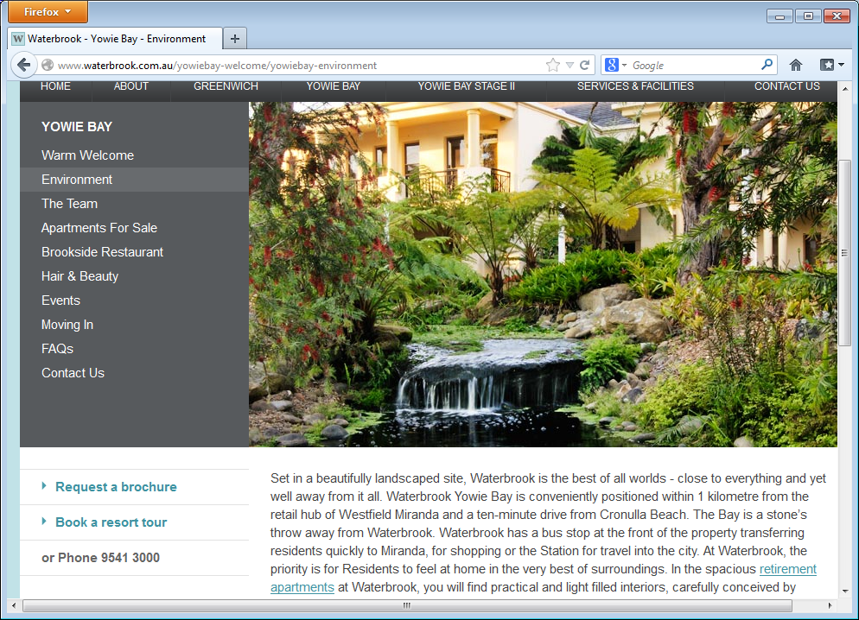
Waterbrook
19 Wyralla Rd, Yowie Bay (near Miranda)
Chamber Music Concert
2pm Sunday 10 April 2016
Cost $15 includes refreshments
Producer: Joan Bolton

