- program -
BEETHOVEN Sonata No 3 Op 12 No 3
(1) Presto (2) Andante scherzoso più allegretto (3) Allegro molto
violin George Carrard piano Murray Brown
22’
Three Short Pieces for Solo Guitar
(1) BACH Prelude for Lute BWV 998 (2) PIAZZOLA Milonga del Ángel
(3) HOUGHTON Kinkachoo - I Love You
guitarist Joseph Littlefield
9’
Richard STRAUSS Songs
(1) Secret Invitation (2) All Souls' Day (3) Dreaming in the Twilight
(4) Tomorrow (5) Dedication
mezzo soprano Jo Burton piano Murray Brown
16’
--- interval ---
BOËLLMANN Finale from Quartet in F minor Op 10
(4) Finale – allegro
Piano Quartet: violin Debbie Gray viola John Keller
cello Sharon Maennl piano Neil Semmler
9’
PIAZZOLA/SEMMLER Libertango
Piano Quartet
9’
Songs from the Movies
KERN/GERSHWIN Long Ago and Far Away
WARREN/GORDON Serenade in Blue
KERN/MERCER Dearly Beloved
mezzo soprano Jo Burton piano Murray Brown
7’
Popular Songs
arranged by John KELLER
GERSHWIN Embraceable You
ROGERS/HART My Funny Valentine
HANLEY Zing Go the Strings
Piano Quartet
9’
REFRESHMENTS
~~~~~~~~~~~~~~~~~~~~~~~~~~~~~
BEETHOVEN (1770-1827) Sonata No 3 in Eb major Op 12 No 3
Beethoven was 28 when he published his well-known piano sonata “Pathétique” Op 13 and the sonatas for piano and violin Op 12. The early opus numbers do not imply immaturity. Today’s sonata, Op 12 No 3, is a work of genius. With the nimble-mindedness and energy of youth, it has a richness of invention unsurpassed by the older Beethoven and, for that matter, sensibly by any other composer.
The first movement of No 3 has some pyrotechnical passages for the piano, but is also a game of catch-up between piano and violin, both instruments urging each other on to new deeds, breaking away from the tradition at the time of piano sonata with violin accompaniment. The second movement in C major is very much the emotional core of the work, and reminiscent of an operatic aria - the violin sings in long lines over a murmuring accompaniment, then trades roles with the piano. The short, cheerful finale is a rondo on a cheeky theme. Unexpectedly, the middle section falls into a minor mode and hints at some brief, mild conflict between the instruments. This is soon swept away by another surprise, a fugal treatment of the main theme that leads straight into a brief, high-spirited coda. http://en.wikipedia.org/wiki/Johann_van_Beethoven#Life, http://www.classicfm.com/composers/beethoven/guides/beethovens-life-timeline-part-1/, http://en.wikipedia.org/wiki/Beethoven_and_Mozart, http://www.softschools.com/timelines/beethoven_timeline/94/, http://boulezian.blogspot.com.au/2014/09/programme-essay-for-beethoven-violin.html
Three Short Pieces for Solo Guitar
J S BACH (1685-1750) wrote BWV 998 containing this prelude in 1735, about the same time Book II of his Well-Tempered Clavier. (2) PIAZZOLA (1921–1992) wrote Milonga del Ángel for a stage play Tango del Angel, in which an angel heals the spirits of the residents of a shabby Buenos Aires neighborhood. A milonga is a proto-tango, lighter and gentler than the more familiar form. https://www.allmusic.com/composition/milonga-del-%c3%a1ngel-tango-from-%c3ngel-series-mc0002659864 (3) Joseph, a senior teacher in the Sydney Guitar School, will play the gentle piece Kinkachoo - I Love You as a tribute to his late friend Phillip HOUGHTON (1954-2017). Melbourne born Phillip had little compositional training, but his pieces have been recorded by the renowned Australian guitarist John Williams. A Kinkachoo is a mythical bird.
Richard STRAUSS (1864 - 1949) Five Lieder
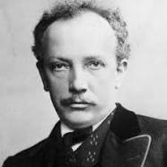
Although well-known for his operas (Salome, Der Rosenkavalier, Capriccio, etc) and colourful orchestral works such as Don Juan and the Alpine Symphony, Richard Strauss was also a composer of many songs (lieder in German), most of them written before 1900. He was not an innovator like Schubert and Wolf, but had a very good understanding of the expressive possibilities of the female voice. His elegiac final work, the Four Last Songs for soprano and orchestra, is very frequently performed.
Strauss had a very long career as an orchestral and opera conductor, as well as being a prolific composer. He was appointed conductor of the Berlin Philharmonic at the age of 30 and became director of the Vienna State Opera in 1919.
Strauss married the soprano Pauline de Ahna in 1894. Although she was famously eccentric and outspoken, it was a happy marriage and she was a source of inspiration to him. He preferred the soprano voice to all others, and all his operas contain important soprano roles.
Today's selection ranges from the Wagnerian impulsiveness of the opening song, Secret Invitation/Heimliche Aufforderung, through the quiet intensity of All Souls' Day/Allerseelen and Tomorrow/Morgen and the nature painting of Dreaming in the Twilight/Traum durch die Dämmerung to the almost religious fervour of the final song, Dedication/Zueignung. They all demonstrate his ability to convey heartfelt emotion through an expressive vocal line and a richly textured accompaniment.
BOËLLMANN (1862 –1897) Finale from Quartet in F minor for Piano and Strings Op 10
A French organist and composer of Alsatian origin, Boëllmann’s professional life spanned 16 years of his short life of 35 years, during which he composed about 160 pieces of many genres. The Piano Quartet Op 10 was written around 1890 and won a prize from the Society of Authors, Composers and Publishers of Music (SACEM). Neil discovered this work while researching quartets for piano and strings. He discovered two things: (a) how excellent this quartet is in entirety, and (b) what a good composer Boëllmann was! https://en.wikipedia.org/wiki/L%C3%A9on_Bo%C3%ABllmann, http://www.musimem.com/boellmann.htm (Google Translated), https://societe.sacem.fr/en
PIAZZOLA (1921–1992)/SEMMLER Libertango
Astor Piazzolla was an Argentine tango composer, bandoneon player, and arranger. He revolutionised the traditional tango into a new style “nuevo tango” incorporating elements from jazz and classical music. A virtuoso bandoneonist, he regularly performed his own compositions with a variety of ensembles. Nuevo tango was distinct from the traditional tango in its incorporation of elements of jazz, its use of extended harmonies and dissonance, its use of counterpoint, and its ventures into extended compositional forms.
Neil was searching for a piano quartet arrangement of a work by Piazzola, but found nothing suitable for this concert. He remembered a simplified arrangement for piano solo of Libertango and used this as a basis. Whilst unmistakably Libertango, his arrangement traverses a number of different moods and colours. The simple harmony over a descending base line provided a rich starting point. The tango rhythmic figures with dramatic melody provides a unifying canvas. https://en.wikipedia.org/wiki/Astor_Piazzolla https://en.wikipedia.org/wiki/Libertango
Songs from the Movies
Long Ago and Far Away composed by Jerome Kern/lyric by Ira Gershwin featured in the 1944 film Cover Girl and the 1946 film Till the Clouds Roll By. Serenade in Blue by Harry Warren/Mack Gordon was introduced in the 1942 film Orchestra Wives. Dearly Beloved by Jerome Kern/Johnny Mercer was in the 1942 film You Were Never Lovelier. https://en.wikipedia.org/wiki/Long_Ago_(and_Far_Away), https://en.wikipedia.org/wiki/Serenade_in_Blue, https://en.wikipedia.org/wiki/Dearly_Beloved.
More popular songs
John Keller arranged these songs to fit the piano quartet for this concert and hopes you enjoy them.
concert organisers George Carrard and Joan Bolton
If you wish to be on the mailing list for these concerts,
please email george_carrard@yahoo.com.au or
write to George Carrard 22 Lansdowne Pde Oatley 2223
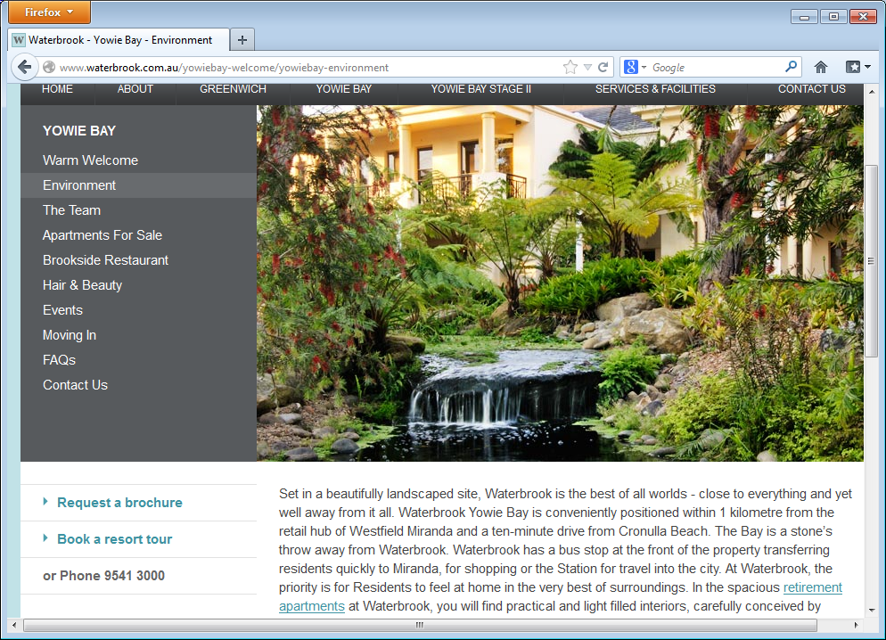
Ardency Aroona
formerly Waterbrook, 19 Wyralla Rd
Yowie Bay (near Miranda) tel: 95413000
Sunday Concert
2 pm Sunday 15 October 2017
Cost $15/10 includes refreshments

