Amateur Chamber Music Society
acms-australia.org/concerts/
— PROGRAMME —
BEETHOVEN String Trio Op 9 No 1
(1) Adagio/Allegro con brio (2) Adagio, ma non tanto, e cantabile
(3) Scherzo, Allegro (4) Presto
violin Marjorie Hystek viola Paul Whitbread
cello Hugh Wilson
27’
GRIEG Sonata in A minor Op 36
(1)Allegro agitato (2) Andante molto tranquillo
(3) Allegro molto e marcato
cello Benjamin Avanzi piano Ben Chan
27’
— Interval —
Pieces for Soprano, Clarinet, and Piano
SCHUBERT Romance
KALLIWODA Homeland Song
WALKER The Great Trees (ii and iv)
soprano Sarah Arnold clarinet Andrew Cousins
piano Ross MacDonald
20’
BEETHOVEN Piano Quartet Op 16(a) in E flat
(1) Grave/Allegro, ma non troppo (2) Andante cantabile
(3) Rondo: Allegro, ma non troppo
violin Marjorie Hystek viola Paul Whitbread
cello Meg Corlette piano Christine Edwards
26’
— refreshments —
BEETHOVEN String Trio Op 9 No 1
Beethoven’s string trios, written in the period 1797-98, were some of his earliest work conceived at a “symphonic” scale. They pre-dated the quartets and Beethoven considered them his finest work at the time of publication. There is much evidence that these trios served as a vehicle to develop his compositional style later used in the string quartets.
The trio opens with an introductory Adagio, setting the stage for a work of grand proportions (like the first movement of Beethoven’s Symphony No.1 written in 1799). This transforms into a lively, inventive movement which skillfully uses the sonority of just three instruments to give a big sound. A slow movement in the key of E major provides contrast and melodic beauty. There is an enigmatic scherzo and the work concludes with a lively presto.
GRIEG Sonata for Cello and Piano in A minor Op 36
This sonata is perhaps one of the most passionate and expansively Romantic sonatas ever composed for the instrument. Grieg dedicated the piece to his brother John, an amateur cellist with whom he had not been on good terms for some time. Unfortunately, there was no reconciliation, and it was another cellist, Ludwig Gritzmacher, who premiered the work with Grieg at the piano on October 22, 1883.
The first movement begins with a brooding, agitated theme, which quickly dissolves into a tender second theme more characteristic of Grieg – warmly lyrical, very Norwegian. The movement has a wide emotional range, heightened by the unusual inclusion of a mini cadenza for the cellist. The lyrical Andante draws its opening theme from Homage March composed by Grieg as incidental music to a play about King Sigurd Jorsalfar of Norway. There is a stormy middle section before the processional theme returns at the end of the movement. The final movement begins with a brief recitative-cadenza for solo cello, which ushers in a vigorously rustic folk dance. As in the first movement, the finale traces a huge expressive trajectory.
Pieces for Soprano, Clarinet, and Piano
Please see attached sheet.
BEETHOVEN Piano Quartet Op 16(a)
This was written in 1796 as a Quintet for Piano and winds and subsequently re-arranged by the composer in 1801. Amusingly, it is mostly known through an unauthorised arrangement as a string quartet, made by the publisher, Artaria, falsely designated Op 75.
As a piano quartet, this is an immensely satisfying and uplifting work. After a slow introduction echoing symphonic beginnings, the piano introduces a joyful theme that is developed throughout the first movement. The slow movement is essentially a set of variations in which each instrument plays the theme with an adaption reflecting their particular tone colour, followed by some exquisite ensemble moments. The final rondo is energetic, not the least for the piano, which has a number of passages which would not be out of place in the piano concertos.

Concert organiser Marjorie Hystek
Following the concert, audience members are invited to
stay for light refreshments (wine, juice and savouries)
Entry donation: $15 ($10 concession and seniors)
For information on future concerts, go to the website
www.acms-australia.org
(or Google “ACMS chamber music society Australia”)
and click on “Concerts”
All chamber music players are welcome to join the
Amateur Chamber Music Society. If interested, go to the website and click on “Join Us”, or write to ACMS Membership Secretary
PO Box 584, Balgowlah NSW 2093
or email membership.secretary@acms-australia.org

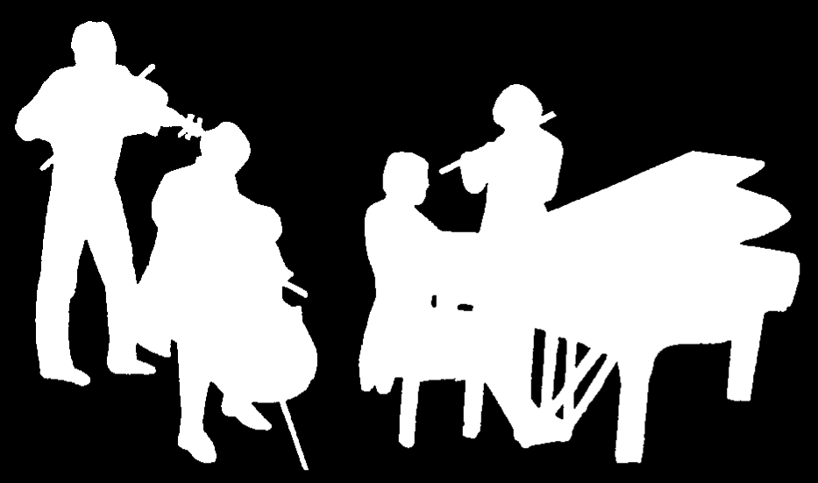
The Kirribilli Centre
www.thekirribillicentre.org
Amateur Chamber Music Society
acms-australia.org
presents
Chamber Music Concert
5 pm Sunday 7 October 2018

