— CONCERT —
2:30pm 14 April 2013
“Waterbrook” 19 Wyralla Rd, Yowie Bay
- program -
LISZT Concert Étude No3 D-flat major S144
piano Ivan Foo
7'
MENDELSSOHN Sonata in F major (1838)
(1) Allegro vivace (2) Adagio (3) Assai vivace
violin George Carrard piano Christine Edwards
22’
MOZART Rondo in A minor K511
RACHMANINOV Elegie in E-flat minor
No1 of Fantasy Pieces Op3
piano Neil Semmler
10+6’
interval
RAVEL Eight Noble and Sentimental Waltzes
(1) Modéré – très franc (2) Assez lent – avec une expression intense (3) Modéré (4) Assez animé (5) Presque lent – dans un sentiment intime (6) Assez vif (7) Moins vif
(8) Epilogue: lent
piano John Keller
15’
FRANCK Fourth Movement from
Sonata in A Major
(violin part arranged for cello)
(4) Allegretto poco mosso
cello Sharon Maennl piano Neil Semmler
7’
MENDELSSOHN (arr LISZT) On Wings of Song Op34
piano Neil Semmler
4’
Notes
LISZT (1811-1886) Concert Study No3 in D-flat major S144
Publishers, not Liszt, gave this work a nickname A Sigh to emphasise that it is a concert piece, not just a study. It is very popular and has been used in seven films, including Shine.
MENDELSSOHN (1809-1847) Sonata in F major (1838)
Felix Mendelssohn was born in Hamburg, Germany, into a distinguished and affluent family of bankers, intellectuals and artists. A child prodigy, he published a piano quartet Op1, with a beautiful slow movement, written when he was thirteen years old. By fourteen he had written 12 sinfonias for strings – one of which was recently recorded by the Australian Chamber Orchestra. At 17 he was in his third year at Berlin University studying philosophy under Hegel and publishing his much loved Overture to Midsummer Nights Dream. A constant stream of work continued throughout his relatively short and very busy life of 38 years. At 26, he moved to Leipzig to take charge of the Gewandhaus Orchestra. There, he met the 25-year-old Schumann, whose family lived there, and they became friends. Seven years later, Mendelssohn helped Schumann with a revision of the scherzo of his celebrated piano quintet, performed here last year. As Gewandhaus director, Mendelssohn championed both historical and modern works - of the former he is particularly well known for reviving interest in the music of Bach.
At 29, he wrote his Sonata in F Major (1838) to be presented today. Mendelssohn did not publish it and it has no opus number, so it is usually defined by the date. Famous violinist Yehudi Menuhin was given a photostat copy of the original manuscript, performed it in 1952 and had it published it in 1953. No evidence has been found that this sonata was ever played before Menuhin’s “premiere”, except perhaps by Mendelssohn and a friend (or family member) in the year it was written. It was in 1838 that Mendelssohn started work on his famous violin concerto, which he completed six years later. Did Mendelssohn keep the sonata from publication in case he wanted to use some of the ideas in his concerto? In the event there are a few similarities between the concerto and the sonata.
The sonata is an extremely ambitious work, concerto-like for both instruments while remaining true to the form. The result is both coherent and exhilarating. The first movement, Allegro vivace, is fraught with drama from the beginning. The piano begins with a statement of dotted-rhythm sequences moving up. Then the violin takes over the melody while the piano ripples. The two climb and fall as they trade melody and accompaniment back and forth. A reflective Adagio follows. Mendelssohn led a very busy life and busyness is a word that comes to mind especially when playing the last movement Assai vivace – the music scurries along – there is hardly time to breathe!
About Mendelssohn’s interest in Bach: there are passages in this work that are reminiscent of the sequences of modulations in Bach’s Brandenburg Concerto No3, recently performed at Waterbrook.
MOZART (1756-1791) Rondo in A minor K311 (1787)
A Rondo in music is a piece made from a recurring tune or theme, interspersed with other musical ideas.
This Rondo has a theme that becomes more improvisatory and expressive with each recurrence. Even the other ideas/sections, after optimistic beginnings, become rather unsettled. The work concludes with a recitative-like coda where the opening tune is restated in a more sombre context.
Mozart’s father fell in March 1787, just a month or two before he died. The Rondo K311 is dated 11 March 1787. Perhaps the impending loss of his father inspired this emotional and moving piece of music. NS
RACHMANINOV (1873-1943) Elegie in E-flat minor (1892)
The Elegy is the first of five piano solo pieces from Fantasy Pieces (Morceaux de Fantaisie) Op3 that the 19-year-old Rachmaninov composed in the year that he graduated from the Moscow conservatorium. The work shows remarkable maturity.
RAVEL (1875-1937) Eight Noble and Sentimental Waltzes
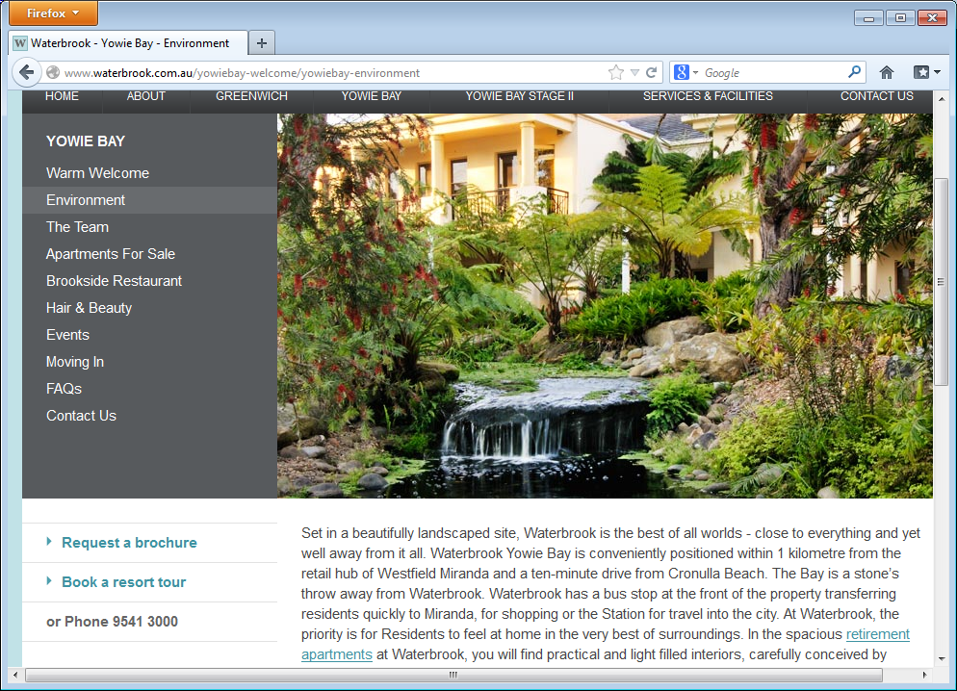
Maurice Ravel unashamedly imitated good models, in this case Schubert’s Valses nobles Op77 and Valses sentimentales Op50, in which Ravel strove to imitate Schubert’s clarity of writing. At the beginning of the score, he added a quotation from a novel of 1904, “the delightful and always novel pleasure of a useless occupation”. This short description holds the key to understanding the piece. This coy recognition of “art for art’s sake,” typifies the attitude of many in the years just before World War I.
Waterbrook
19 Wyralla Rd, Yowie Bay (near Miranda)
Chamber Music Concert
2:30pm Sunday 14 April 2013
Cost $10 (all tickets) includes refreshments

Producers: Joan Bolton and George Carrard
Publicity: Sonja Mallam
The eighth waltz is a résumé of the previous waltzes. The music fades quietly into silence and is marked “en se perdant” (losing itself).
FRANCK (1822-1890) Fourth Movement from Sonata in A-major
Although Franck was 63 years old when he wrote the sonata, it belongs to the group of his most famous works, all written when he was in his 60s. He continually revised his compositions, producing only a few, but all beautifully crafted.
In the last movement, the main melody is heard in canonic imitation between the instruments, and recurs in a rondo-like manner to a triumphant and soaring conclusion. It has been described as "a magnificent example of canonic writing, simple, majestic and irresistible in its ample, beautifully wrought proportions".
MENDELSSOHN (arr LISZT) On Wings of Song Op34
Originally written when Mendelssohn was 26, probably as a piano piece, adapted two years later as a song based on a romantic poem of the same name by Heine. The work quickly became popular, and its gorgeous melodic line makes it an ideal candidate for instrumental arrangement, especially by violinists.

http://www.pristineclassical.com/LargeWorks/Chamber/PACM037.php, http://en.wikipedia.org/wiki/Felix_Mendelssohn, http://www.laphil.com/philpedia/music/violin-sonata-f-major-felix-mendelssohn.
http://www.mozartproject.org/compositions/ko_86_91.html http://en.wikipedia.org/wiki/Rondo_for_Piano_No._3_%28Mozart%29
http://www.richard-dowling.com/RavelVNS.html
http://en.wikipedia.org/wiki/Violin_Sonata_(Franck)#Structure

