— CONCERT —
2:30pm 15 September 2013
“Waterbrook” 19 Wyralla Rd, Yowie Bay

- program –
Three Pieces inspired by Water
DEBUSSY Reflections in the Water
HYDE Valley of Rocks
LISZT Fountains at the Villa d'Este S163
piano Iona Luke
7+6+8'
SCHUMANN Three Fantasy Pieces Op73
(1) Tender and with expression (2) Light and lively
(3) Quick and fiery
clarinet Lindsay Wanstall piano Kris Spike
15’
interval
SCHUBERT Piano Trio No2 in E-flat major D929
(1) Allegro (2) Andante con moto
(3) Scherzo (4) Allegro moderato
violin George Carrard cello Robyn Godfrey
piano Murray Brown
40’
~~~~~~~~~~~
Notes
Claude DEBUSSY (1862-1918) Reflections in the Water from
Images Book 1
Debussy composed two volumes of Images for the solo piano. Reflets dans L’eau (Reflections in the Water), composed in 1905, is the first of three piano works in the first volume of Images. The title of the work is descriptive of the mood and atmosphere Debussy wanted to invoke. Characteristic of French impressionist music of the time, this work features vague and fast changing harmonies which invokes an imagery of water constantly moving and changing its shape.
Miriam HYDE (1913-2005) Valley of Rocks
Adelaide born, long-time resident of Sydney, Miriam Hyde is one of the best loved of Australian composers. The 100th anniversary of her birth was celebrated early this year on the ABC. Valley of Rocks (1975), her best known composition, was directly inspired by a her visit in 1974 to the Valley of Rocks near the village of Lynton in North Devon, England. The work describes the night falling on the timeless and brooding coastal scene, with the stream winding and wind stirring leaves amongst inspiring rock formations along the valley.
Franz LISZT (1811-1886) "The Fountains of the Villa d'Este" third year from Years of Pilgrimage S163
Les jeux d'eaux à la Villa d'Este (The Fountains of the Villa d'Este) was composed in 1877 and was the fourth work in the third suite Troisième année. The work depicts the many fountains in the gardens of Villa d’Este, a villa in Tivoli outside of Rome. Midway through the piece Liszt cites John 4:14 ‘But whoever drinks the water I shall give will never thirst; the water I shall give will become in him a spring of water welling up to eternal life’, giving the work a religious context. Années de pèlerinage (Years of Pilgrimage, S160, S161, S163) is a set of three suites for solo piano. It is widely considered a masterwork and summation of Liszt's musical style. The third volume is especially notable as an example of his later style. Composed well after the first two volumes, it displays less showy virtuosity and more harmonic experimentation.
Robert SCHUMANN (1810-1856) Three Fantasy Pieces Op73
Robert Schumann was a German composer, one of the greatest of the Romantic Period (1825-1900). He was a virtuoso pianist until a hand injury forced him to concentrate on composition. Schumann's early compositions were exclusively for piano until 1840. After this time he composed for piano and orchestra, many art songs (Lieder), four symphonies, an opera, and orchestral, choral and chamber works.
Fantasy Pieces Opus 73 was written in 1849, as three short pieces, originally entitled Night Pieces, “Soiréestücke” in German, for Clarinet in A and Piano.
Franz SCHUBERT (1797-1828) Piano Trio No2 in E-flat major D929
This piano trio, dated November 1827, was first performed at a private party in January 1828 to celebrate the engagement (by some accounts, the wedding) of one of Schubert’s school friends. At times it has a ländler dance flavour, which is appropriate for a party and would have appealed to his friends. It was among the few of Schubert’s late major compositions that he heard performed, and was also one of the few works published before his untimely death at the age of 31.
The work is long, but has many contrasts of energy and volume. Stravinsky, when once asked if he was put to sleep by the prolixities of Schubert, replied: “Why should it matter if, when I awake, it seems to me that I am in Paradise?”
The first movement is quite long, but holds interest with its inventive patterns and changes of key, particularly in the middle section. It opens in a manner conventional at the time, establishing the home key of Eb major, but develops in a way that would have surprised Mozart and probably Beethoven. The movement (and the whole work) demonstrates Schubert's melodic inventiveness and capacity to re-invent his themes through constant changes of key.
The second movement is set at a walking pace (andante con moto) and is one of Schubert's most beautiful and most well-known compositions. It has been used in at least six films, notably Stanley Kubrick's Barry Lyndon. Out of the opening cello theme Schubert constructs a story of passion contrasted with sections of “ethereal loveliness”, to use Berger’s words.
The dance-like third movement scherzo and trio (allegro moderato) unfolds in a canon between the piano and strings; even when the exact imitation evaporates, the spirit of friendly emulation remains. The thump of a distant country band can be heard in the trio section. Schubert marked its opening with emphatic chords over a soft background. As usual the trio is followed by a short version of the scherzo section.
The finale (allegro moderato) is expansive and complex. The bright opening theme moves with only a short transition to the more dark-spirited second tune. After this runs its course, Schubert abandons the conventional recapitulation back to the first theme and instead introduces the melody from the second movement on the cello, but with an entirely different accompaniment on the piano and violin to suit the new tempo and context. This structure was ground-breaking and has been copied, perhaps not so effectively, by later composers. As usual Schubert cannot resist repeating his melodies in different keys, re-introducing the second movement theme again before the spirited ending.
Players
The players are members of the Amateur Chamber Music Society, which organises monthly concerts at the Kirribilli Neighbourhood Centre.
Iona Luke was a 2011 finalist in the International Piano Competition for Outstanding Amateurs hosted by the Van Cliburn Foundation. She works as a corporate solicitor.
Lindsay Wanstall BMusEd teaches private students and trains a youth band.
Kristofer Spike BMusEd is a prize-winning composer, pianist and piano teacher. His compositions are often heard on ABC Classic FM and other fine music stations. Many of his compositions have been inspired by his concern for sustainability issues and he now combines his performing and environmental advocacy in concerts called Wind Energy.
Robyn Godfrey BMusEd is a busy teacher of cello and music. She is a co-founder of the Palm Court Orchestra which has played at many of Sydney’s “happening” events and regularly performs classical music with the Orpheus Quartet in NSW.
Murray Brown has performed with many singers and instrumentalists for the Lieder Society of Victoria and the National Lieder Society. He has had a diverse career in arts organisations, including the ABC, the Australian Film Commission, Arts Training Australia and the Heritage Council of NSW, and is currently a policy advisor with the Australian Institute of Architects.
George Carrard chose a working life in science and engineering with music as a counterpoint. He grew up in Perth, arrived in Sydney in 1968, led the Sutherland Shire Symphony Orchestra for 16 years, played in the Sydney Concert Trio in music clubs throughout NSW. Now retired, his main interest today outside music is in doing anything to mitigate the catastrophic consequences of global warming.
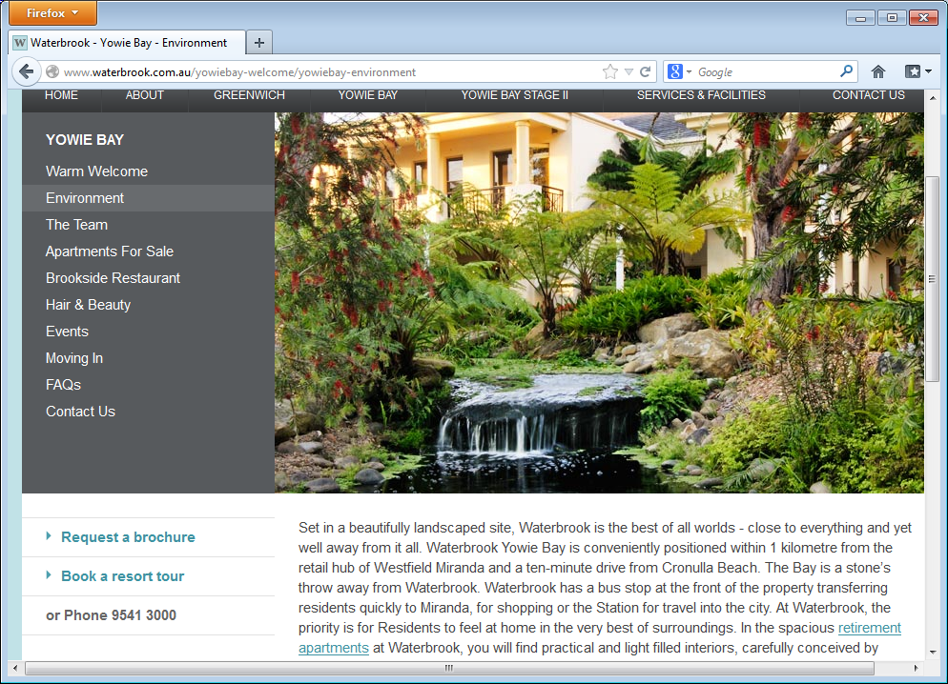
Waterbrook
19 Wyralla Rd, Yowie Bay (near Miranda)
Chamber Music Concert
2:30pm Sunday 15 September 2013
Cost $10 (all tickets) includes refreshments

Producers: Joan Bolton and George Carrard

Melvin Berger, Guide to Chamber Music, Dover 2001
http://www.allmusic.com/composition/piano-trio-no-2-in-e-flat-major-d-929-op-100-mc0002368068

