— CONCERT —
2pm 3 May 2015
“Waterbrook” 19 Wyralla Rd, Yowie Bay
- program -
BRAHMS Quintet in F Minor Op34
(1) Allegro non troppo (2) Andante, un poco adagio
(3) Scherzo: Allegro - Trio
(4) Poco sostenuto⎯Allegro non Troppo⎯Presto, non troppo
violins George Carrard and Sonja Stadnik viola John Keller
cello Sharon Maennl piano Neil Semmler
37'
interval
TURINA Quartet in A minor Op67
(1) Lento - Andante mosso - Lento - Andante mosso
(2) Vivo - Lento – Vivo (3) Andante - Allegretto - Allegro molto
violin Sonja Stadnik viola John Keller
cello Sharon Maennl piano Neil Semmler
17’
GERSHWIN/arr SEMMLER Three Short Pieces
(1) Nice Work If You Can Get It (2) Foggy Day
(3) I’ve Got Rhythm
the quintet players
12’
Notes
BRAHMS (1833-1897) Piano Quintet in F Minor Op34
Johannes Brahms’s grandfather was an innkeeper and was comfortably off. Against all advice and because his ability was not outstanding, Johannes’s father was determined to make a career as a musician resulting in a life of poverty. Despite their poverty, the family gave the children as much education as they could afford. Johannes started learning the cello and piano as a child and, when his outstanding natural talent was recognised, he was given piano tuition by the best piano teachers. According to a contemporary, he performed a piano sonata that he either composed or improvised when he was 11 years old.
They lived near the Hamburg waterfront, populated by sailors and prostitutes who frequented sleazy dance halls. As an adolescent as young as 13, Johannes left school and had to contribute to the family income by playing the piano in the dance halls. The pay was a low amount plus alcohol ad libitum. Instead of taking to alcohol, Johannes blotted out the terrible surroundings by reading poetry on his music stand while he was playing the dance music from memory.
In his late teens, Johannes conducted choirs, gave public concerts in Hamburg and, aged 19, he made a concert tour as a pianist. At 20 he was on a concert tour accompanying a violinist during which he met the famous violinist Joachim as well as the composers Liszt and Raff (at Weimar, 300km from Hamburg). Shortly after, with a letter of introduction from Joachim, Brahms met the composer Robert Schumann and his wife, the international performing pianist Clara, and family. They became close friends. Robert praised Brahms so much in the journal that he edited (Neue Zeitschrift für Musik), that Brahms had to work very hard to match his reputation.
In his 20s, Brahms held concurrent positions in the Detmold court and conductor of a ladies choir in Hamburg. During this time he took walks in the forest near Detmold and made drafts of what was to become his Piano Quintet Op34. The first draft was a two-cello-string-quintet, which Joachim and friends performed; they judged that it needed a piano to enhance its dramatic elements. The next draft was for two pianos, Op34a, which is still performed today. Clara Schumann advised that it needed the string sonorities, and Brahms cast it and published it in the final form for piano quintet - he was now 31. Joachim wrote “The quintet is beautiful beyond words a masterpiece of chamber music the like of which we have not seen since the year of 1828 [the date of Schubert’s death].
The quintet succeeds through the balance it strikes between intense individualism of ideas and breadth of organisational plan. It bursts with harmonic and melodic opulence and rhythmic variety. The first movement with its dramatic undertones begins with a simple unison melody of piano, violin and cello, gradually intensifying throughout. It is powerful, majestic and intensely serious. The second movement is the least complex, with its swaying melody—a lyrical song without words, reminiscent of Schubert. The third movement, the Scherzo, with it's swift changes of mood and overwhelming climax; it is rhythmic, insistent, restless, and complex - using a fugue to build to one of the climaxes. In contrast, it is followed by a lyrical, mysterious introduction to the Allegro non troppo, which develops folksy elements into an exciting conclusion. A lady who heard Brahms play it told one of Brahms’s biographers, Peter Latham, that Brahms played the Allegro non troppo section with great deliberation. Latham writes that most modern combinations play it too fast.
Brahms by Peter Latham (Dent, 1975), The Compleat Brahms edited by Leon Botstein (Norton 1999) http://en.wikipedia.org/wiki/Johannes_Brahms https://www.andrews.edu/~mack/pnotes/2012%20Concerts/sep2212pnotes.html
TURINA (1882-1949) Quartet in A minor Op67
Born in Seville, the capital of Andalusian Spain, Turina showed exceptional talent at the keyboard from the age of four. After success as a pianist and composer in Seville, he studied in Madrid for three years and started a lifelong friendship with fellow student Manuel de Falla. During further formal study in Paris, his expatriate musical friends de Falla and Albeniz persuaded him to relinquish French influence and incorporate Andalusian folk elements into his compositions. With the outbreak of the world war of 1914, he returned to Madrid. In the following years he taught composition, gave concerts, directed a tour of Spain for Diaghilev’s Russian Ballet, worked as musical director at the Royal Theatre, wrote an encyclopaedia of music, became a music critic, and directed an orchestra, with which he premiered his own compositions. In 1930, he was appointed a professor of composition at the Madrid Conservatorium and a year later he wrote his Quartet in A Minor. Like all of his chamber music, this piece is infused with the characteristic grace of Spanish folk music, containing numerous Gypsy and Andalusian references. The three movements of the piano quartet are approximately equal in length and have no formal structure. Most listeners are captivated by the fiery rhythms and beautiful lyricism of the piece.
http://www.naxos.com/person/Joaquin_Turina/24829.htm, http://www.chambermusicwilliamsburg.org/garth2Notes.html
GERSHWIN (1898-1937)/arr SEMMLER Three Short Pieces
George Gershwin, named after his grandfather Jakov Gershowitz of St Petersburg, was the son of immigrants to America. He lived a usual childhood existence for children of New York tenements - running around with his boyhood friends (mainly in the Yiddish Theatre District), roller skating and misbehaving in the streets. Remarkably, he cared nothing for music until the age of ten. When his parents bought a piano for his brother, Ira, it was George who monopolised it, much to Ira’s relief. His natural talent showed early and from his late teens he got work arranging and composing for piano rolls, musicals, and film. At 26 (1924) he wrote his much loved “Rhapsody in Blue” orchestrated by a colleague.
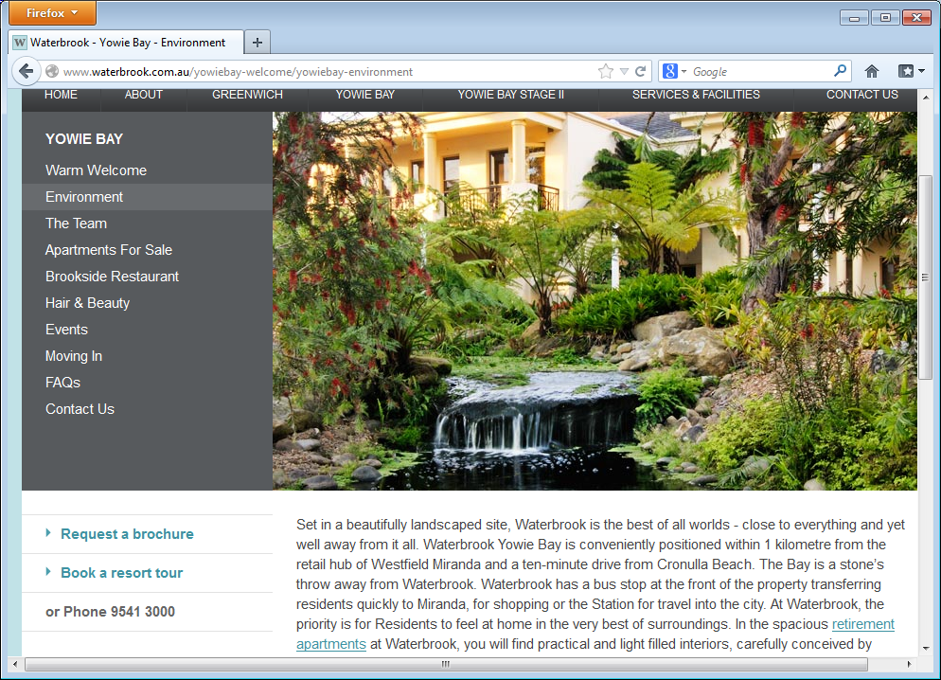
Nice Work If You Can Get It was one of nine songs written for the film “A Damsel in Distress” starring Fred Astair (who sang it). Lyrics were by his brother Ira. The film was produced in 1937, the year that Gershwin died (aged 39, from a brain tumour). Foggy Day originally titled A Foggy Day in London Town was written for the same film, again sung by Fred Astair. I’ve Got Rhythm, a hit, was notably used in a 1930 musical Girl Crazy. Its chord progression, known as the "rhythm changes", is the foundation for many other popular jazz tunes.
Waterbrook
19 Wyralla Rd, Yowie Bay (near Miranda)
Chamber Music Concert
2pm Sunday 3 May 2015
Cost $15 includes refreshments
Producer: Joan Bolton
http://en.wikipedia.org/wiki/George_Gershwin, http://en.wikipedia.org/wiki/I_Got_Rhythm
Postscript: George Gershwin’s grandniece, Lisa-ann Gershwin, works for the CSIRO in Tasmania and recently published a book showing how jellyfish are taking over as the sea temperature warms.
Players
Neil Semmler BMus from the Conservatorium, studied at the Royal Academy of Music in London on a scholarship. Worked back in Australia as a professional musician while completing his UTS Computer Systems Engineering degree. He now works full-time in the Information Technology industry.
George Carrard worked in science and engineering with music as a counterpoint. Originally from Perth, he led the Sutherland Shire Symphony Orchestra for 16 years and now concentrates on chamber music. Today, his main interest outside music is doing anything to mitigate the catastrophic consequences of global warming.
Sonja Stadnik grew up in the Shire and started learning violin aged 10. Playing classical music is a hobby which she treasures. She plays in the Sutherland Shire Symphony Orchestra, works full time teaching English to adult migrants and is a mother of two high school children.
John Keller originally from Bundeena, studied piano and viola in the USA on a scholarship. He now teaches piano in Caringbah, is a member of the Sutherland Shire Symphony Orchestra, and has performed with the orchestra both as conductor and solo pianist.
Sharon Maennl BMus studied organ with her father before the age of five and gave organ recitals from 13. Later, her love of string sonority extended to the cello, which became her stringed instrument of focus. She teaches both organ and cello.

